**Project Design Phase-II**

**Technology Stack (Architecture & Stack)**

|  |  |
| --- | --- |
| Date | 6.11.2022 |
| Team ID | PNT2022TMID46328 |
| Project Name | Estimate the crop yield using data analytics |
| Maximum Marks | 4 Marks |

**Technical Architecture:**

The Deliverable shall include the architectural diagram as below and the information as per the table1 & table 2

**Example :**

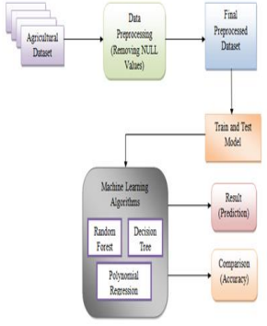

Table-1: Components & Technologies:

|  |  |  |  |
| --- | --- | --- | --- |
| **S.No** | **Component** | **Description** | **Technology** |
| 1. | User Interface | User interacts with the application using a web app | python |
| 2. | Database | Data Type, Configurations etc. | MySQL, NoSQL,Excel etc. |
| 3. | Cloud Database | Database Service on Cloud | IBM Cognos analytics. |
| 4 | File Storage | Storage of user files in cloud account | IBM Block Storage or Other Storage Service or Local File system |
| 5. | Machine Learning Model | Machine learning model is used to identify the estimation of crop yield using datasets | prediction Model. |
| 6. | Infrastructure (Server / Cloud) | Application Deployment on Local System / AI Local Server Configuration  AI Server Configuration | Local, Cloud Foundry, Kubernetes, etc. |

Table-2: Application Characteristics:

|  |  |  |  |
| --- | --- | --- | --- |
| **S.No** | **Characteristics** | **Description** | **Technology** |
| 1. | Open-Source Frameworks | Machine learning frameworks is used to train a predictive model | PyTorch,Open-cv,Google Colab. |
| 2. | Scalable Architecture | The website traffic limit must be scalable enough to support 2 lakhs users at a time | 3-tier |
| 3. | Availability | Minimizing errors and maximizing accuracy | distributed servers |
| 4. | Performance | .Program should be less time consuming | number of requests per second |